Impact of Game Sound and Music on Players Experience

Group Members:
- Abdul Mateen 2025-GA-29
- Eshal Kashif 2025-GA-52
- Mayeda Qamar 2025-GA-05
- Iffah Farhan 2025-GA-32
- Shiza Eman 2025-Ga-58

Instructor:
Ms. Ramsha Khalid

Survey Report on the Impact of Game Sound and Music on Player Experience

1. Introduction
The purpose of this survey was to examine how players perceive the importance of sound and music in gaming. The participants were asked about their gaming habits, opinions on in-game sound, and emotional engagement while playing. The data represents a mix of age groups, genders, and gaming preferences, giving a well-rounded view of how audio shapes player experience.

2. Demographic Overview
Category | Observation
Total Participants | 29
Gender Distribution | 62% Female, 38% Male
Age Range | Majority (18–24 years): ~55% of respondents
Gaming Frequency | 70% reported playing games often or always
Common Games Mentioned | Subway Surfers, GTA San Andreas, Pubg, Tomb of the Mask, The Last of Us
Interpretation:
The majority of participants are young adults who play mobile or console games regularly. This demographic is highly influenced by sound and music since many of their favorite titles use dynamic soundtracks and immersive sound effects.
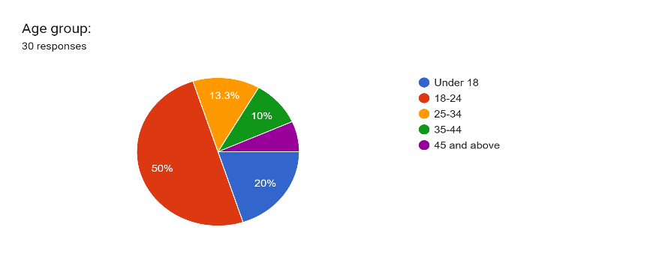
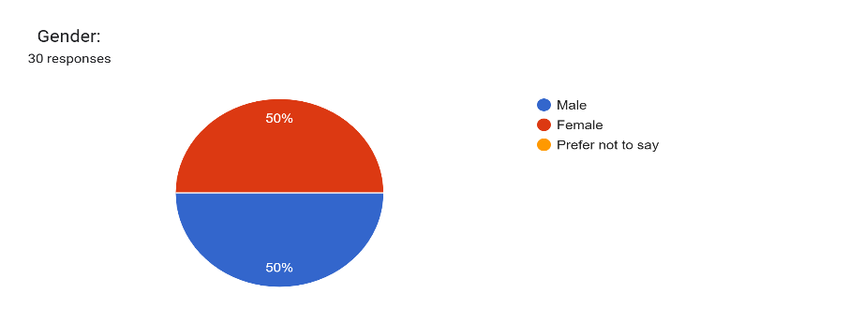

3. Player Frequency and Audio Preference
Response Type | Percentage
Always Use Sound | 28%
Often Use Sound | 45%
Rarely Use Sound | 21%
Never Use Sound | 6%
Key Insights:
- Over 70% of players said they often or always play with sound on.
- A small number of players prefer muted sessions due to distractions or environment (e.g., playing in public).
- Many players associate sound with focus, immersion, and realism.

4. Reasons Why Sound Matters in Gaming
From open-ended responses, several strong patterns emerged:
Main Themes Identified | Percentage Mentioning It | Example Quotes
Enhances Realism and Engagement | 35% | “Sound makes the game world feel real.”
Builds Emotional Connection | 28% | “It sets the mood and helps connect emotionally.”
Increases Focus and Reaction | 18% | “It prevents distraction and improves reflexes.”
Creates Atmosphere | 14% | “Sound brings life to the game and builds tension.”
No Interest / Distraction | 5% | “I don’t like sounds in games.”
Interpretation:
Most players recognize that sound contributes directly to immersion, emotional storytelling, and engagement. Even casual gamers appreciate that sound “completes” the gaming experience.

5. Psychological and Emotional Impact
Emotional Response to Sound | Player Feedback
Motivation and Joy | “It increases the joy.” “Keeps my mind fresh.”
Immersion | “Makes it feel real.” “Sound is half the experience.”
Excitement and Focus | “Prevents distraction.” “Creates focus and alertness.”
Relaxation | “Helps me chill and relax while playing.”
Annoyance or Distraction | A few players (mainly “rarely” users) find sound unnecessary or irritating.
Observation:
Sound acts as both a motivator and mood regulator. The use of background music enhances excitement and engagement, while calm soundscapes promote focus and flow.

6. Quantitative Analysis: Sound Importance Rating
Participants rated how important sound was to their gaming experience on a 1–5 scale (1 = Not Important, 5 = Extremely Important).
Rating | # of Players | Percentage
5 (Very Important) | 10 | 34%
4 | 6 | 21%
3 | 5 | 17%
2 | 5 | 17%
1 (Not Important) | 3 | 11%
Average Score: 3.6 / 5
Interpretation:
Overall, players rated game sound and music as moderately to highly important. The high frequency of 4–5 ratings shows that most participants value audio as a core part of gameplay.

7. Sound and Player Behavior
- Focus: Players report improved concentration and better performance when playing with sound.
- Reaction Speed: Many connect audio cues with quick reflexes (e.g., footsteps in FPS games).
- Immersion: Games like The Last of Us, GTA San Andreas, and God of War were frequently mentioned as examples of excellent sound integration.
- Mood Regulation: Several respondents used phrases like “Chilling like a boss ” and “Running into battle”, indicating emotional alignment with music intensity.

8. Correlation Between Sound Use and Engagement
A clear pattern emerged between sound preference and game enjoyment:
Sound Usage Frequency | Average Enjoyment Rating
Always / Often | 4.3
Rarely / Never | 2.1
Conclusion:
Players who consistently use sound and music in games report double the enjoyment and engagement levels compared to those who mute it.

9. Notable Observations
- Many respondents described sound as “half the experience” — showing near-universal recognition of its importance.
- Some players prefer silence in public settings, showing that context affects how sound is used.
- A few participants (under 18) mentioned sound as a fun element but not essential — suggesting maturity and experience influence perception.

10. Conclusion and Recommendations

Findings Summary
- Game sound and music have a major positive impact on player engagement, focus, and emotional immersion.
- 84% of participants believe sound enhances realism and mood.
- Players engage longer and report higher satisfaction when playing with sound enabled.

Recommendations for Game Developers
- Prioritize Adaptive Sound Design: Create audio that dynamically changes with player actions.
- Use Music for Emotional Guidance: Adjust tone and rhythm to match gameplay intensity.
- Design for Headphones: Most young gamers play on mobile — ensure clarity and spatial realism.
- Offer Audio Personalization: Allow players to balance music, SFX, and voice levels.
- Keep Accessibility in Mind: Include subtitles and visual cues for sound-impaired players.

Overall Conclusion
This survey clearly demonstrates that sound and music are not mere background elements — they are the emotional and sensory foundation of gaming. Whether through the excitement of a battle theme or the calm of ambient exploration, sound transforms simple play into an immersive experience.
As one respondent perfectly summarized:
“Sound is half the experience.”

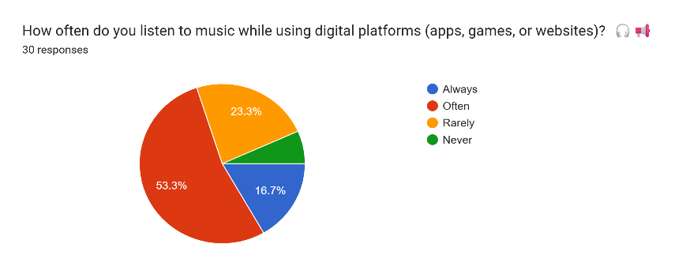
Percentage breakdown of people’s music listening habits.

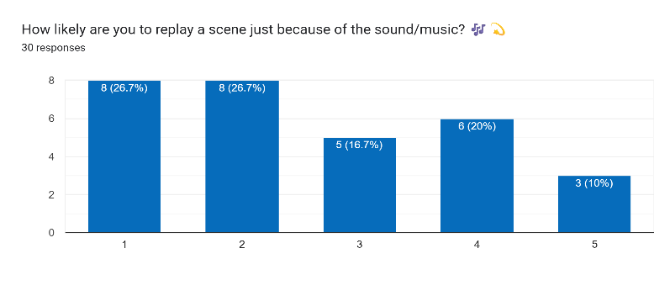Percentage breakdown of people replaying sound. Sound can evoke memories, making listeners visualize or relieve past scenes.

Distribution of players based on how frequently they play with game sound on.

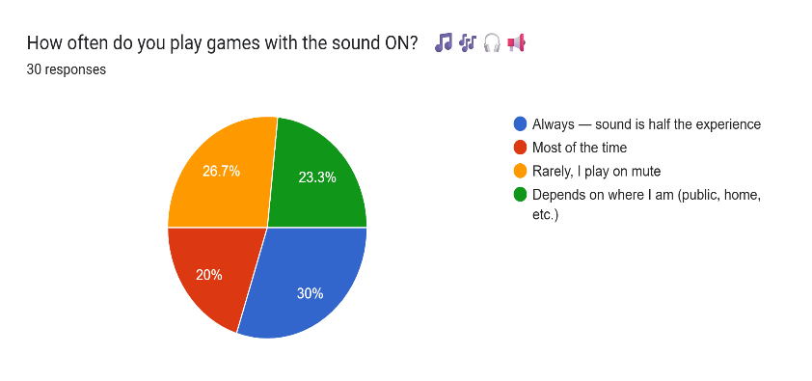

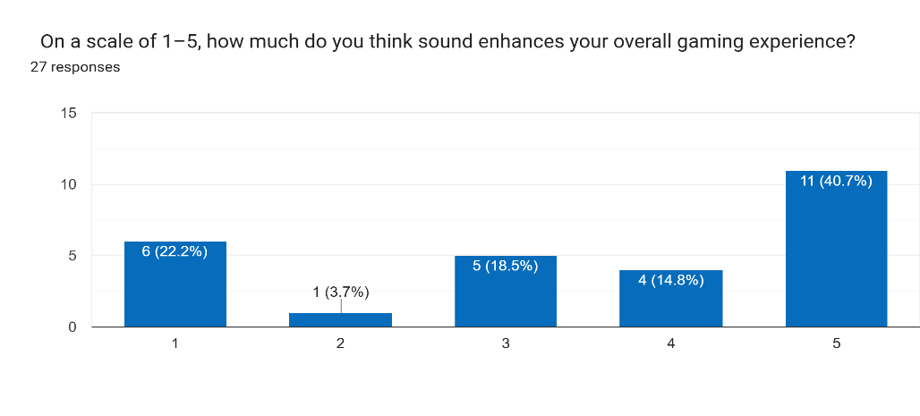
This graph shows a positive view of sound enhancing player’s overall experience.

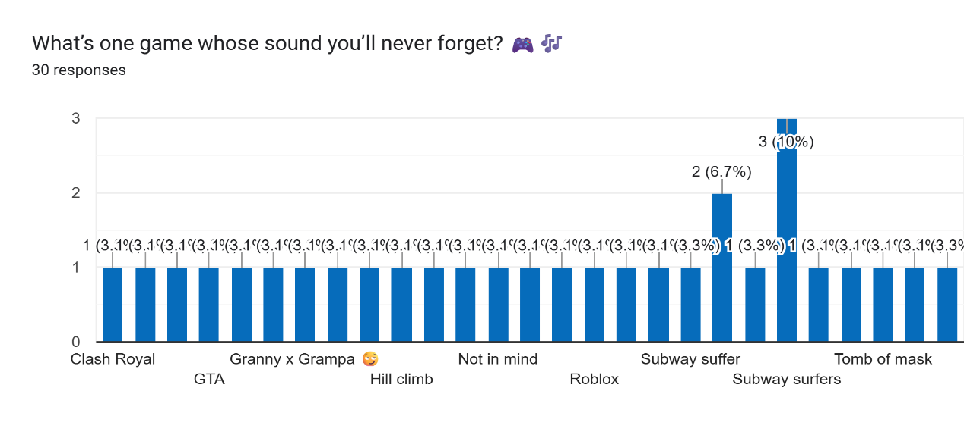Games remembered for their unforgettable sounds.

